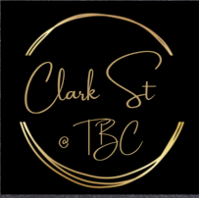

Antipasto board $75
a centre piece consisting of marinated Olives, pepperoni, salami, prosciutto, sun dried tomatoes, cheese, roasted nuts, carrot and celery sticks, tapenade with wafer crackers and herb bread sticks
Sandwich platter $65
A freshly made platter full of all of your favourites, these consist of: egg and lettuce, ham tomato cheese and chicken, lettuce and tomato, these will be made on both white and grain bread
Cheese platter $90
A selection of cheese that consist of Brea, cheddar and blue cheese served on a platter with sliced fresh fruit pair, grapes, dried apricots, cashews, marinated olives, hummus with a bowl of wafer crackers
Hot food platter $50
Party pies, sausage rolls, spinach and cheese triangles, spring rolls, dim sims, cocktail fish.
Gourmet hot food platter $90
Spinach and ricotta pastries, mouth-watering beef sliders, honey bbq pork bao buns finished with sesame seeds, sweet and sticky honey soy chicken kebabs

